Q and A from March 1 Webinar
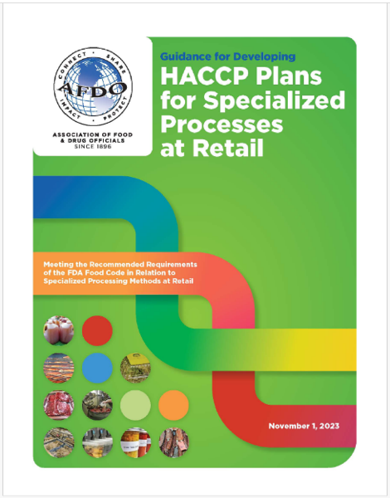
Guidance for Developing HACCP Plans for Specialized Processes at Retail

1] We have a lot of inquiries on freeze-drying - candy, ice cream, meats, full meals, BBQ sauces (made into powders to reconstitute with water for hikers/campers)
Freeze-drying is a preservation method that typically involves freezing a food, then reducing the pressure and increasing the temperature to cause the frozen water in the food to sublimate (transition from a solid to a gas). This removes the majority of the water from the food, which inactivates or inhibits the growth of microorganisms. Freeze-drying does not kill bacteria or other microorganisms; they remain viable, but dormant, despite the extreme conditions of freeze drying.
Additionally, freeze-dried foods are often packaged under vacuum or in airtight containers, which further reduces the risk of contamination. Nearly any food item can be freeze dried (e.g. fruits, vegetables, herbs, meats (cooked and raw), eggs, dairy, meals, casseroles, desserts). Vegetables should be blanched prior to freeze drying to prevent discoloration. Food high in fat content, high in sugar content, and baked goods such as breads, cakes, and muffins do not freeze dry well and should be avoided.
Freeze drying produces high quality foods that are safe as long as they are handled properly prior to freeze drying, dried thoroughly, packaged appropriately, and used or prepared correctly once the packaging is opened. Any bacteria or microorganism on raw foods prior to freeze drying will reactivate upon rehydration. Therefore, food items that are traditionally cooked before eating must also be cooked before eating as a freeze-dried food.
Regulatory authorities may require retail firms that freeze dry products to obtain a HACCP plan and variance depending on the food product that is freeze-dried and the process used. For example, freeze dried fruits or vegetables might utilize a chlorine treated flume water to wash the fruit or vegetable product to be processed. The concentration of chlorine might be considered a critical control point. Foods that are considered TCS and ready-to-eat are considered higher risk, and may be more likely to be required by the regulatory authority to have an approved HACCP plan.
Here are some cautionary issues from manufacturers to consider including the following:
- Freeze-drying big chunks of food - The larger the pieces of food, the longer they will take to dry. Not to mention, big chunks of meat may go rancid due to their fat content. For the best freeze drying results, make sure to cut food into small uniform pieces. Doing this ensures that moisture is completely removed and that each piece is fully processed.
- Combining meat and other foods in the freeze-drying chamber - While it’s fine to freeze-dry different types of food at once, as long as they have similar flavors, avoid mixing raw meat with other products to avoid cross-contamination.
- Not cleaning your freeze dryer after every use - Neglecting cleaning may lead to clogs and malfunction over time.
- Not storing freeze-dried foods properly - Freeze-dried products can last up to 25 years depending on how you store them. This is why ensuring proper storage of your foods is crucial to maximizing their longevity. Right after freeze drying, food should be placed in an airtight container to provide protection from light, moisture, and odor.
- Overloading your freeze dryer trays - Keep in mind that more food means more drying time is required. As a best practice, check the recommended load size for your freeze dryer.
- Freeze-drying foods high in fat and sugar - A common mistake with freeze drying is doing it on fatty and sugary foods. Because fat goes rancid sooner, your freeze-dried food will last only a few years. If you want to freeze-dry meat (e.g. an already-cooked steak), drain or remove the extra fat prior to processing it. Sugary items like honey and jams will remain sticky even with increased drying time. So, avoid freeze drying them.

2] What is the difference between spray drying and freeze drying?
Spray drying is a thermal method widely used in the food industry to produce a dry powder from a liquid. On the other hand, freeze-drying is a non-thermal method that is commonly used for the dehydration of heat-sensitive food through the combination of freezing and vacuum drying.

3] Is sour dough / injera included in the fermentation processes?
Sourdough is slow fermented bread which does not require commercial yeast in order to rise. Instead, sourdough bread is made with a live fermented culture (sourdough starter) containing only “wild” (naturally occurring in the raw food) yeast, which acts as a natural leavening agent. Making sure the sourdough starter is healthy is important for safety. If the sourdough starter does not have a strong enough population of good bacteria and yeast, it is possible for the starter to go bad.
Injera is a sour fermented pancake-like flatbread with a slightly spongy texture, traditionally made of teff flour. Dosa and naan are produced in a similar manner, but from different ingredients. All use lactic acid bacterial fermentation, and the resulting products are either baked or fried as a flatbread.
These fermented bread products are not specifically included in the fermentation section of the AFDO Guide at this time. However, the general guidelines provided there for other products fermented using only naturally occurring bacteria and yeast would also apply to these products. Fermented food with lactic acid is considered generally safe. Further, fermented foods produced with good manufacturing processes and have the appropriate acid, salt, and sugar control pathogenic microorganisms effectively.

4] With sous-vide processing, is the meat kept in the same vacuum packaging during the entire process of cooking, cooling, and cold storing?
Yes, Sous-vide foods are vacuum packed and usually immersed in hot water for cooking. They are generally plated and served following cooking but can be cooled and then stored in the same package.
Because of mild processing, sous-vide foods may become a public health concern because of microbial hazards from pathogenic bacteria Listeria monocytogenes, Clostridium botulinum, and Bacillus cereus. These pathogenic bacteria and those causing spoilage are controlled by an appropriate combination of heat during processing, rapid cooling, refrigeration during storage, and shelf-life duration. However, the lower cooking temperatures found in 3-401.11(B) of the FDA Food Code are not validated for destruction of viruses such as Norovirus and Hepatitis A. According to CDC data, destroying these viruses requires cooking to above 145ºF and 190ºF, respectively. (See https://www.cdc.gov/norovirus/about/prevention.html and https://www.cdc.gov/hepatitis/hav/havfaq.htm for more information) Employee Health and Hygiene policies should be emphasized at handling steps both before and after cooking for this reason.

5] Would taking an internal temperature of food that is in a vacuum package be compromised with the hole made from the thermometer?
Use of a thermometer would definitely compromise the vacuum package. Sous vide temperature monitoring kits provide self-sealing foam tape that is intended for this application. A needle thermocouple probe is used with the foam tape, and connects either hard-wired or through a Bluetooth connection to the monitoring device.

6] Would seafood that is sous vide packaged and frozen after cooling require a variance due to the requirement that fish must be frozen before, during and after packaging?
Yes, a variance would be required.

7] There has been confusion for which processes require a HACCP plan and no variance or required variance. Is there a chart?
Specialized food processing methods that require a variance and a HACCP plan are:
- Smoking of food as a method of preservation but not if smoking is for flavor enhancement
- Curing of food such as ham, sausages, etc.
- Using food additives to preserve food so that it is not time/temperature control for safety (TCS)
- Operating molluscan shellfish tanks that store/display shellfish that are offered for human consumption
- Undercooking of food other than “whole muscle intact beef” and not wanting to use a consumer advisory
- Custom Processing of animals for personal use in a food establishment
- Sprouting of seeds or beans
- Reduced oxygen packaging, except where Clostridium botulinum and Listeria monocytogenes is a concern and a single barrier, i.e., refrigeration exists
- Preparing, serving or transporting food by another method that is determined by the department to require a variance or HACCP plan.
Specialized food processing methods that require a HACCP plan but no variance are:
- Reduced oxygen packaging, except where Clostridium botulinum and Listeria monocytogenes is a concern and more than one barrier exists
The FD312 Special Processes Course has charts pertaining to variance and HACCP plan requirements.

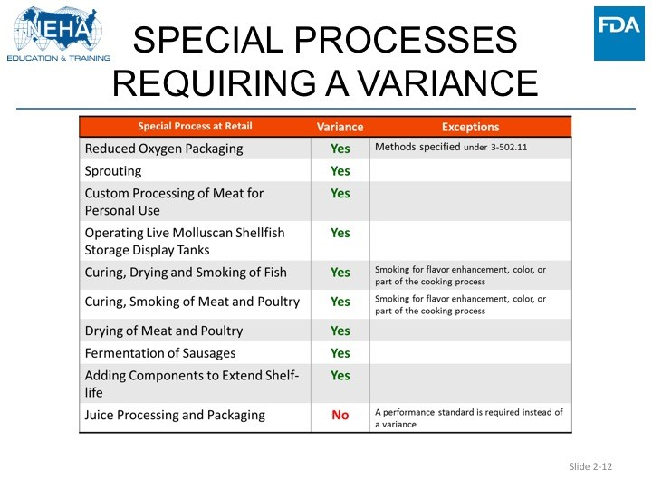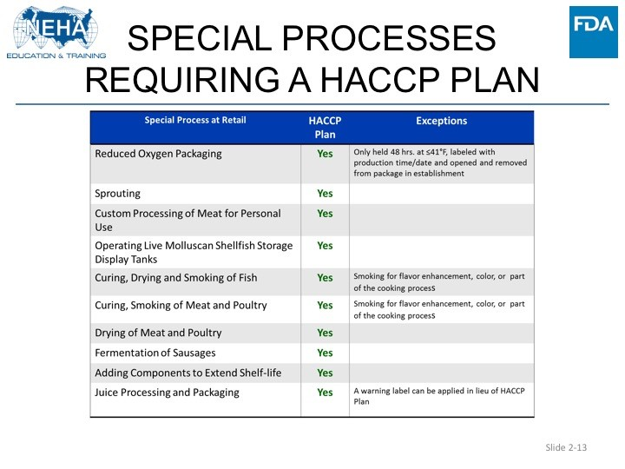

8] Would be very interested in knowing if there is a flow chart or some form of review sheet for various processes for reviewers/approvers?
The FDA312 Special Processes course provides validation and verification checklists for all the retail special processes. The HACCP templates provided at the AFDO special processes webpage provide guidance to operators to assist them in providing complete instructions to support implementation of HACCP plans; that guidance is also very useful for regulatory reviewers to make sure the plans are complete enough to provide the level of control required by the FDA Food Code.
9] Can toxins be reduced in a product is added in a dip shrink tank?
This type of dip tank generates a sleek packaging when vacuum packaged products in special shrink bags are briefly immersed in warm water within the dip tank. This will create an even tighter packaging around the product and ensure moisture is retained so flavor and weight are not lost.
Toxin development from pathogens are controlled by proper time and temperature requirements. If these toxins have been formed, the dip tank warm water would not reduce them at all.

10] We would like information on cold brew?
Cold brew is generally brewed without any heat. Instead, coarse grounds are exposed to water, usually over a long period of time, and typically at room temperature or colder. When coffee grounds (generally produced from roasted coffee beans) are mixed or extracted with water, the resulting product meets the FDA Food Code definition of a TCS food (heat treated plant food). Since cold brew coffee lacks a heat step, the final product is considered a Time/Temperature Control for Safety (TCS) ready-to-eat (drink) food and requires refrigeration unless evidence is provided to the Regulatory Authority to indicate it is a non-TCS food. A HACCP Plan is generally not required at retail. However, when the product is brewed, held, and served above 41˚F, or if it is nitrogen-infused or held in a container with an airtight lid for over 48 hours, the regulatory authority may require a HACCP plan. This area of knowledge is still being developed.
11] Wondering about the hazards with bottling Boba Tea that is made with commercial Boba pearls and not a homemade pearl for wholesale.
Boba tea is a cold served beverage consisting of a tea base, milk or fruit flavor, and edible tapioca or fruit flavored pearls (boba).
Recognized food safety controls for the retail production of Boba Tea include employee health and hygiene practices, thorough cleaning and sanitizing of equipment and utensils, and proper refrigeration and storage.
12] As per the FDA Food Code 3-502.12, raw meats and poultry can be vacuum packaged for up 30 days at 41°F. Is this applicable to plain raw meats only? Many operators like to add spices such as salt, pepper, paprika, and even marinades before they vacuum package it for flavor purposes. Does adding spices like salt and pepper affect the competing organisms of raw meats and poultry? Will the 30-day shelf-life no longer be applicable for these products?
To provide context for the answer: FDA Food Code 3-502.12(B) requires that ROP packaged raw meat products must meet at least one of four characteristics: Aw of 0.91 or less, pH of 4.6 or less, commercially cured by a USDA-inspected processing plant in compliance with 9 CFR 424.21, or have a high level of competing organisms. Marinades are typically rather acidic (generally pH <4.0), and they both provide flavor and help tenderize the meat. Marinades may be commercially processed as acidified foods (thermally processed), or may be ready made in-house (no thermal process, so potentially higher microbial load). If dry spices are used instead of a liquid marinade, that would typically be a dry rub, even if just pepper and salt, but may also include other seasonings such as rosemary, thyme, etc. Those herbs would add their own populations of competing bacteria. The ROP environment helps to infuse the meat with flavors of the seasonings and marinades; refrigeration must still be maintained. The answer to this question is that even with the added marinade or dry seasonings, this process still meets characteristics of the ROP process described in 3-502.12(B), and no variance would be required.

